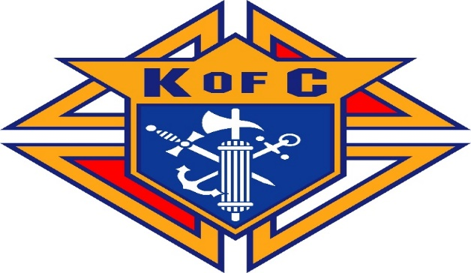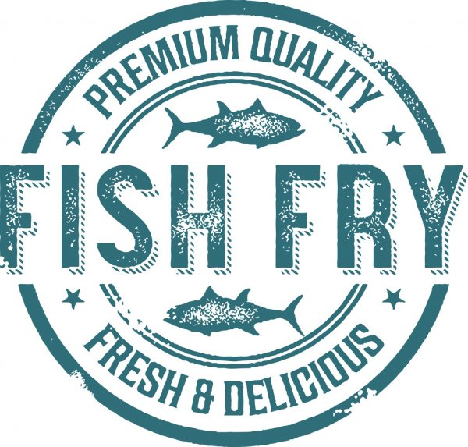
Lake Orion Knights of Columbus
Fish Fry during Lent
Every Friday Starting Friday February 19
Through Friday March 26
St. Joseph Church – Lake Orion
2-piece fish dinner with French fries, tartar sauce, coleslaw and roll $11.00

Mac and Cheese dinner $5.00
Cash and credit cards accepted
Serving from 4:00 PM to 7:00 PM
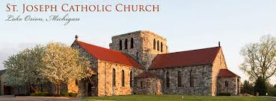
Dinners will be "take out" only and served from Myrick Hall, located in lower level of
the school which is behind the Church.

